**Experiment 2:** Create a simple cloud software application for Property Buying & Rental process (In Chennai city) using any Cloud Service Provider to demonstrateSaaS include the necessary fields such as Buy, Rent, commercial, RentalAgreement , Rental Agreement, Area, place, Range, property value etc.

Step 1:

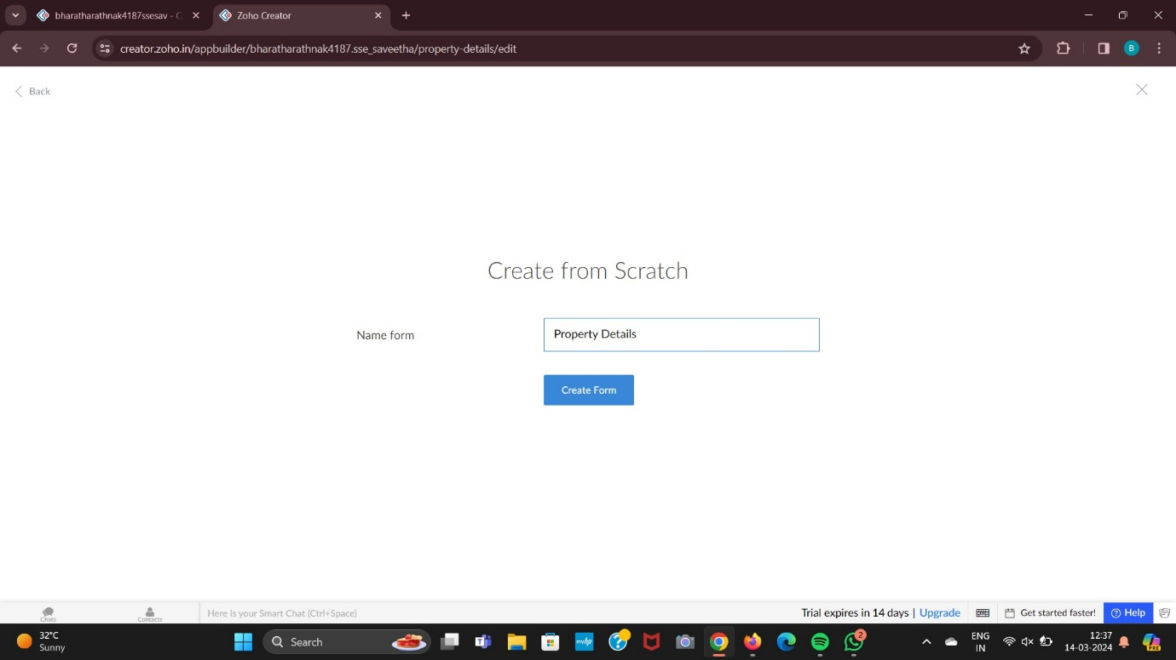

Step 2:

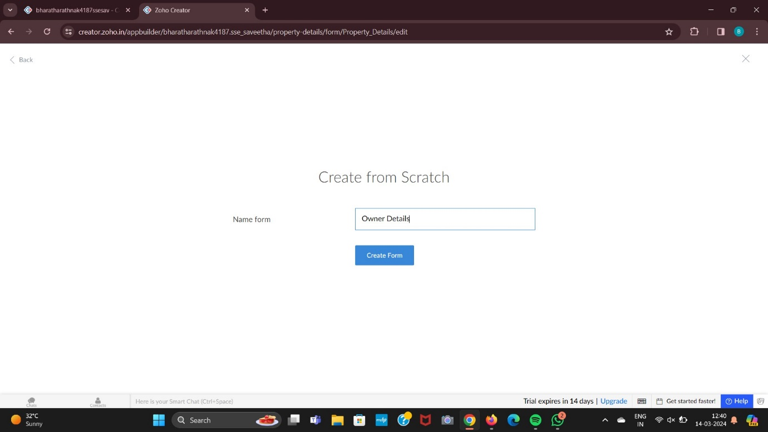

Step 3:

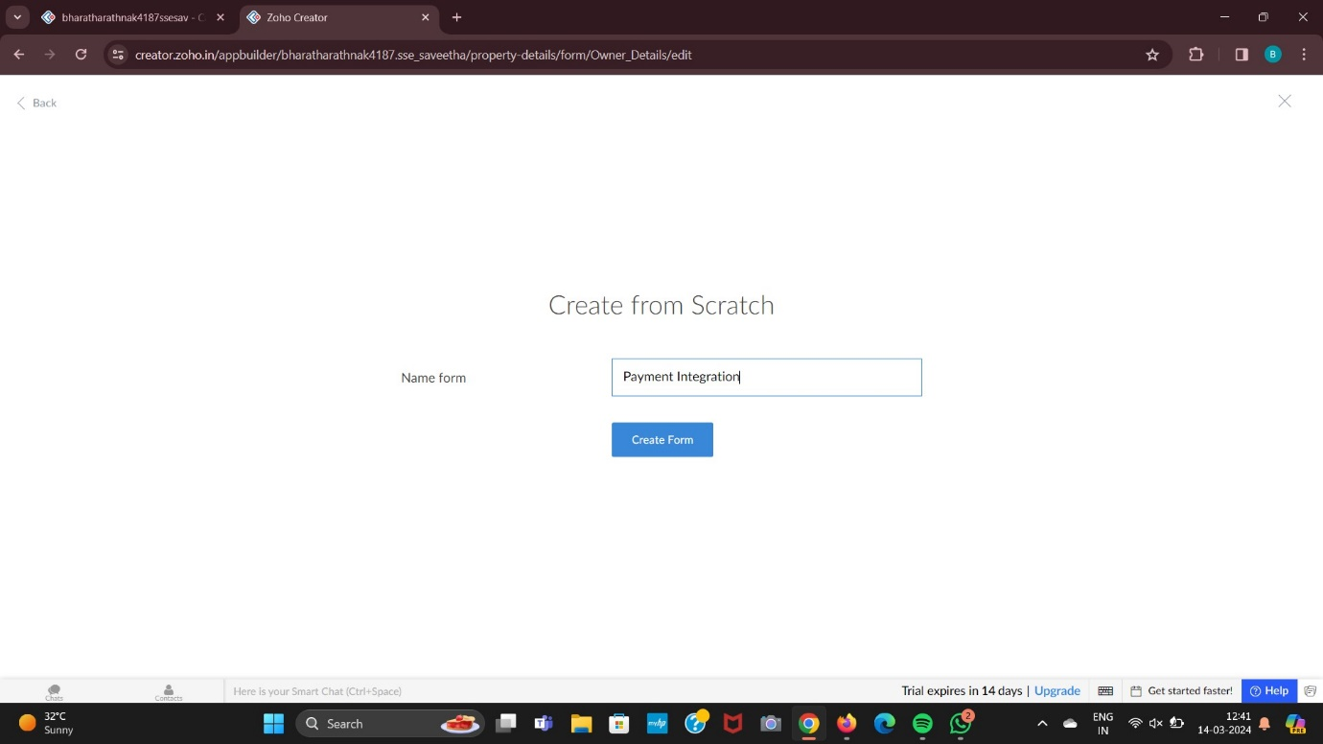

Step 4:

